SEPTEMBER 2025

Making every drop count: lessons in water management

When outdated irrigation systems started limiting efficiency, City of Stirling Nursery Supervisor Ross Burnett tapped into support from Greenlife Industry Australia’s levy-funded extension network.

Combining this with EcoHort principles from the Australian Plant Production Standard (APPS), Ross turned learnings from a Waterwise Workshop into practical, measurable results – cutting water use, boosting plant health and moving the nursery closer to its 10% water-reduction goal.

A nursery with purpose
Owned by the City of Stirling in Perth’s northern suburbs, the nursery produces up to 60,000 plants each year for council projects, natural areas and community programs – with every plant grown for a specific purpose.

Annual production includes:
- horticultural services: 4,000–8,000 trees, shrubs and groundcovers
- city trees: 4,000–5,000 (mostly WA natives)
- conservation and wildlife: 20,000–30,000 tubestock for bushland reserves
- open space design and projects: 3,000–4,000 trees, shrubs and groundcovers
- sustainability programs: 14,000–15,000 verge makeover plants, plus 1,000–2,000 trees for private properties to grow the City’s urban canopy.

With production influenced by seasonal conditions, plant health and resource efficiency are critical. Nothing goes to waste – and that mindset extends to water use.
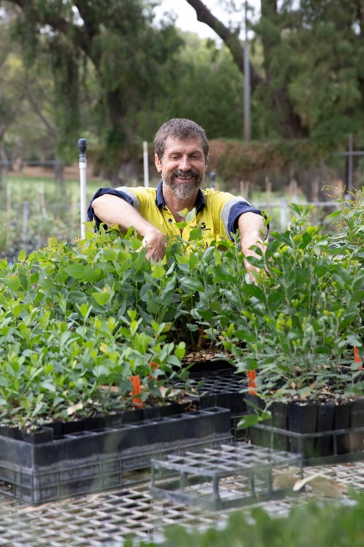
The workshop spark
In early 2025, Ross attended a two-day Waterwise Workshop hosted by Nursery & Garden Industry Western Australia (NGIWA) and sponsored by the WA Department of Water. The course focused on irrigation design, dripper output, line pressure and zoning strategies.

He was encouraged to attend by his local GIA extension officer, who had already been working with him on operational improvements under the levy-funded extension program.

“The environment and industry are always shifting, so we need to be ahead of the game and investing in our skills,” Ross said.

Turning knowledge into savings
Back on site, Ross applied EcoHort – part of the Australian Plant Production Standard (APPS) – to guide his irrigation overhaul.

EcoHort is an environmental best-practice program for production nurseries. It helps growers use resources like water, fertiliser and energy more efficiently, while also protecting the environment and reducing waste.

Although Ross knew the irrigation system wasn’t operating at its best, he didn’t have the tools or knowledge to properly assess it before the workshop. Using EcoHort’s practical checklists and zoning principles, he tested the nursery’s irrigation system – and confirmed his suspicions. The system was delivering more water than plants could absorb, with poor sprinkler uniformity and mismatched irrigation for different plant sizes.

By trialling low-volume drippers and replacing old butterfly sprinklers, Ross has achieved significant results.

Before | After
- Drippers delivering 20L/hour – water bypassing rootballs  - Sprinkler uniformity below 70%  - Mixed tubestock and pots receiving the same irrigation  - Uneven watering causing plant stress and disease risk | - Drippers delivering 0.38–1.9L/hour – targeted to root zones  - Sprinkler uniformity improved to 97%  - EcoHort zoning principles applied for tubestock vs pots  - More consistent plant health and reduced disease risk

The changes have the potential to cut water use by up to 25% while improving plant quality.

Promising green shoots
For Ross, the biggest takeaway is that small, strategic changes – backed by the right advice and training – can deliver big results.

“Water management isn’t just about saving resources. It’s about ensuring every plant thrives and every drop counts,” he said.

With the combined support of GIA’s levy-funded extension network, APPS’ industry best-practice standards, and his local state association, the City of Stirling Nursery is improving operational efficiency and contributing to the City’s broader sustainability targets.

ENDS

